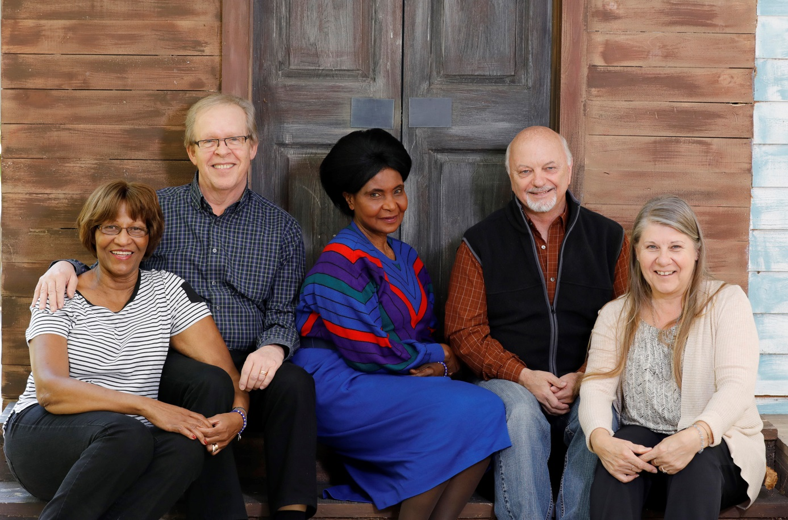

Glenda and Roger La Fleur Olsson, Genevieve Mamai, Frank and Trudy Bonack.